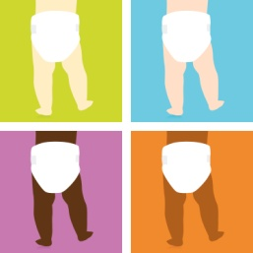
Planning a Diaper Drive
Make it fun and educational!

- Decorate a central collection area with baby items. A playpen or crib makes a great collection bin.

- Kick off the drive with a high profile event or appeal.

- Have a short-term drive with specific goals, or collect diapers on an ongoing basis.

- Collect pennies, nickels, or dimes, with a chart showing how many are needed to buy one diaper (about 25 cents)

- Plan an event. Rather than collecting diapers, have a dance, bake sale or other event, with proceeds going to the Diaper Bank.

- Encourage contests between classes, grades, departments, teachers vs. students. Set goals and monitor progress.

- Use a Diaper Drive as a project for children and youth to learn goal setting, organization, and marketing skills

- Teach the concepts of poverty and philanthropy. Discuss the cost of raising a family, and the cost of diapers and other necessities. Teach children that they can make a difference in the life of someone they don’t even know.

